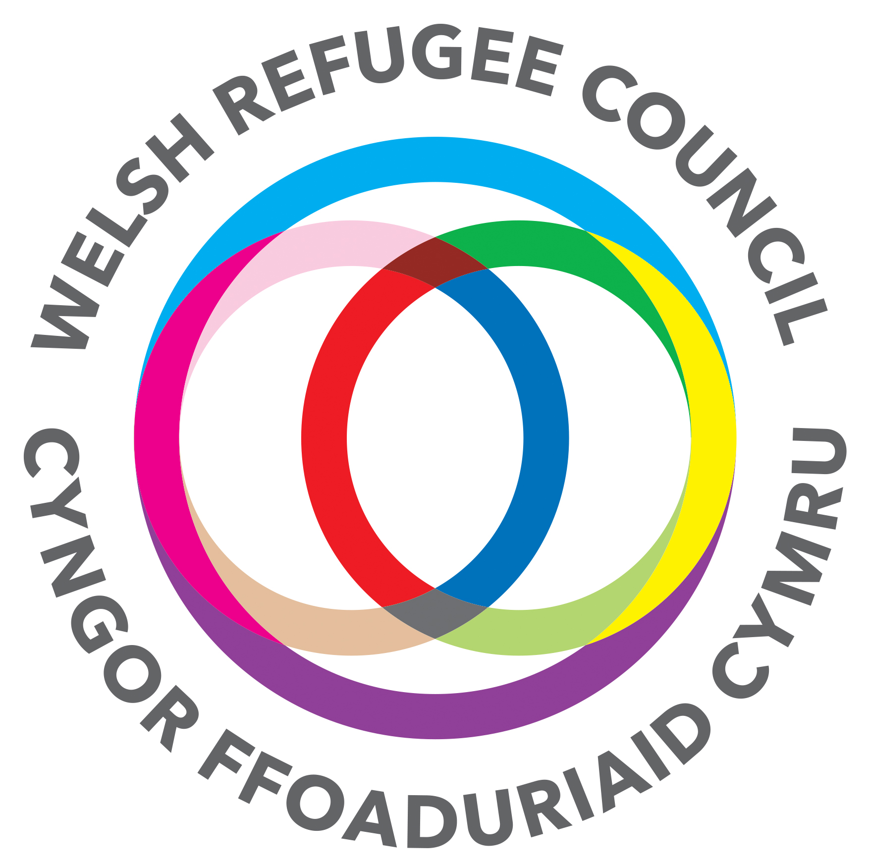

Welsh Refugee Council
Job Description

Job Title: Advice and Support Casework Assistant

Report to: Programme and Partnership Manager

Salary £18,200 + 5% pension

Duration Fixed Term until March 2021

Hours: 35 hours per week

Location: Cardiff with support across all dispersal areas

About us: We are the leading organisation in Wales, promoting equality for and fostering good relations towards asylum seekers and refugees. With over 30 years’ experience we are proud of what we stand for, and we look forward to working with you.

Background of the post: With Welsh Government funding, a consortium of organisations led by the Welsh Refugee Council are working together to deliver an Asylum Rights Programme which will improve access to support services and advice for refugees, asylum seekers and migrants across Wales.

Purpose of the post

- This specific post is funded by the National Emergencies Trust (NET) and will assist in delivering the WRC provision under the Asylum Rights Programme funded by Welsh Government. This is done by providing effective advice and support to WRC clients and, as appropriate and within the remit of their professional qualification, to advocate on their behalf
- To support the work of the casework team to provide advice, guidance and signposting to people seeking asylum and people with refugee status on a daily drop-in basis
- To work across the casework team to provide a high level of admin and practical support
- To provide support to a caseload of people seeking asylum on a one-to-one basis
- To work alongside the caseworkers and partner agencies to improve access to mainstream services and improve integration outcomes
- To support and contribute towards the development of the WRC’s advice service as a whole.

Major duties and responsibilities

Client responsibilities
- To ensure that, always, clients are aware of what options are available to them and that they are empowered to pursue their chosen options, and provided with the necessary assistance to access resources
- To help clients with the completion of forms

Caseworker support
To support the caseworkers by:
- Negotiating with agencies, government departments, local authorities, immigration services, solicitors, and other bodies to secure client’s entitlements and/or access to services
- Arranging interpretation as necessary (either directly or by arranging
interpretation through others who are competent and able to meet agreed standards)
- To support the caseworkers to work in partnership with service providers and key stakeholders to provide a holistic approach to meet clients’ needs
- Undertaking administrative tasks in relation to the above ensuring the capture of all client information and statistics
- The management of basic office systems, e.g. client database,
- Recording all activities and contribute to qualitative and quantitative reports on a regular basis and as required for monitoring and evaluation

Development
- To participate in staff training, development, and appraisal, as agreed with the line manager
- To prepare for and actively engage in the support/supervision and appraisal process provided by the Programme and Partnership Manager
- To attend external and internal meetings relevant to the service, as agreed with the Programme and Partnership Manager (these meetings will usually be in the locale, but may be held in other parts of Wales or the UK)

Good governance
- To carry out all duties in accordance with the principles of the WRC’s Confidentiality Policy and within agreed norms of impartiality and boundaries
- To abide by and to work to WRC’s Equal Opportunities Policy at all times

Flexibility

To deliver the service, a degree of flexibility is needed, and the post holder may be required to perform work not specifically referred to above. Therefore, the post holder is required to be flexible and co-operative in carrying out other reasonable duties and responsibilities. This job specification will be subject to periodic review with the post holder to ensure that it accurately reflects the duties of the job.

Equal opportunities

WRC is committed to equality of opportunity in recruitment, the workplace and service delivery. The post holder is expected to follow WRC’s Equal Opportunities Policy.

Person Specification for Advice and Support Casework Assistant

Quality | Essential & Desirable Requirements of the Post  The below requirements are deemed essential unless highlighted as desirable
Education &  Training | - DBS clearance  - Able to work in an office environment
Job Experience, Knowledge  & Skills | Experience  - An understanding of the sensitivity of service delivery to clients with differing language, cultural and religious backgrounds  - Some knowledge and understanding of the asylum process in the UK, issues affecting people seeking asylum and people with refugee status and of local refugee and asylum seeker provision in Wales  Communication  - Ability to communicate effectively including good listening skills  - Good spoken and written communication skills  - Ability to speak a community language other than English (desirable)  - Ability to provide information and advice efficiently and sensitively to clients  Administration  - Well organised with ability to work under pressure, pay attention to detail, prioritise workloads and meet targets/deadlines  - Experience of providing high level administrative support  - Experience of working in partnership with external agencies  - Ability to absorb complex written and oral information  IT Skills  - Ability to be administratively self-sufficient, including working knowledge of IT packages and basic IT competence  Governance  - Knowledge of child protection and safeguarding issues and procedures (desirable)
Personal  Qualities | - A demonstrable commitment to equal opportunities, diversity, and human rights.  - The ability to work on own initiative and look for new ways of doing things  - Ability to work as part of a team including with interpreters and volunteers

