Wellbeing resources
Simple English and translated versions

With many thanks to colleagues from the Gwent Community Psychology Team and the Gwent Community Health Team who provided most of the information on this document. Other sources are referenced.

For Children

The covi-book for children in 25 languages

https://www.mindheart.co/descargables

Coronavirus - A book with lots of pictures and limited text in English and Welsh for Children with input from Professor Graham Medley Professor of Infectious Disease Modelling and illustrations by Axel Scheffler, who also illustrated the Gruffalo books.
https://www.dropbox.com/s/88ok8kfdjjj4gkn/Coronavirus.pdf?dl=0 or
https://nosycrowcoronavirus.s3-eu-west-1.amazonaws.com/Coronavirus_ABookForChildren.pdf

The Welsh version can be found here: http://atebol-siop.com/media/attachment/Coronafeirws%20-%20Llyfr%20i%20blant.pdf

Time capsule sheets for children - English only, limited text

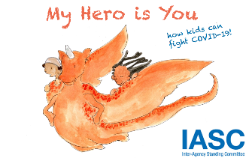
My Hero is you – book for children in 23 languages, promoted by the WHO
https://interagencystandingcommittee.org/iasc-reference-group-mental-health-and-psychosocial-support-emergency-settings/my-hero-you

The book of calm. Lots of pictures, limited text

For Children and adults

5 senses exercise
Diary to record and reflect on exercises

Simple breathing exercise

https://chatterpack.net/blogs/blog/list-of-online-resources-for-anyone-who-is-isolated-at-home

A link for an amazing list of virtual tours, online learning and wellbeing resources. A lot of this is accessible regardless of English language skills

For Adults

Useful information on Public Health Wales website including a section on mental health under the heading – ‘How are you feeling’.

It is available in many languages – click on the box ‘view this information in accessible formats’ on the left hand side and a tool bar appears at top of screen – click on the flag icon and choose your language!
https://phw.nhs.wales/topics/latest-information-on-novel-coronavirus-covid-19/staying-well-at-home/

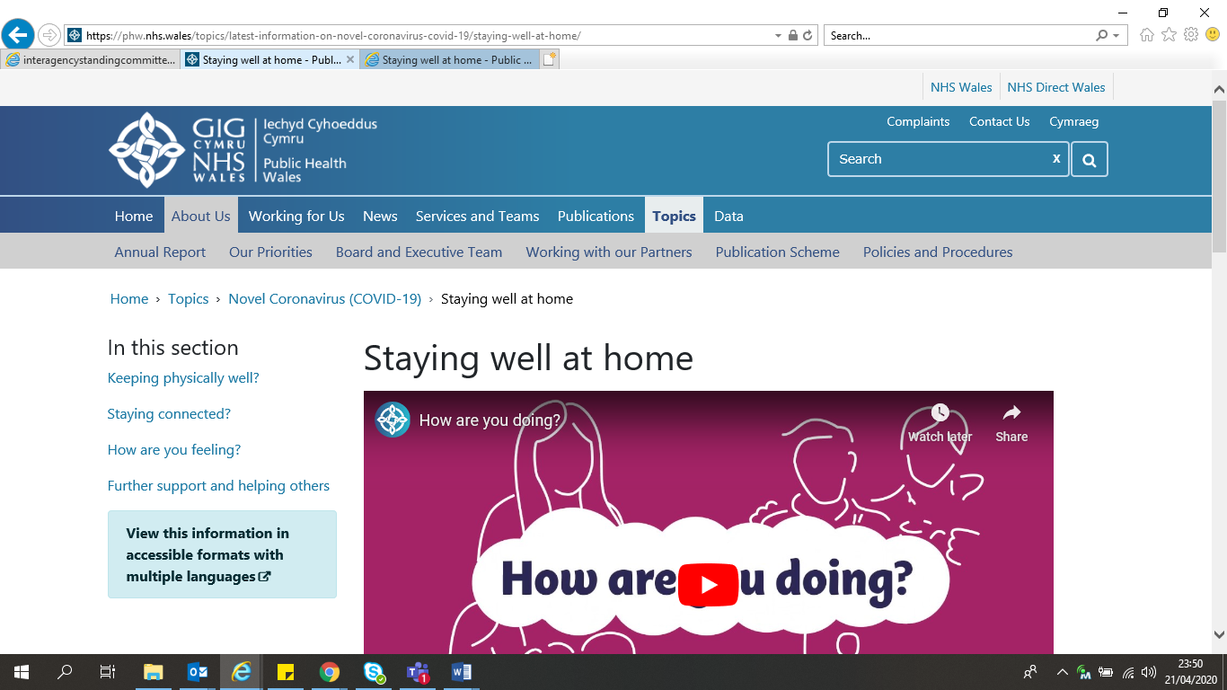

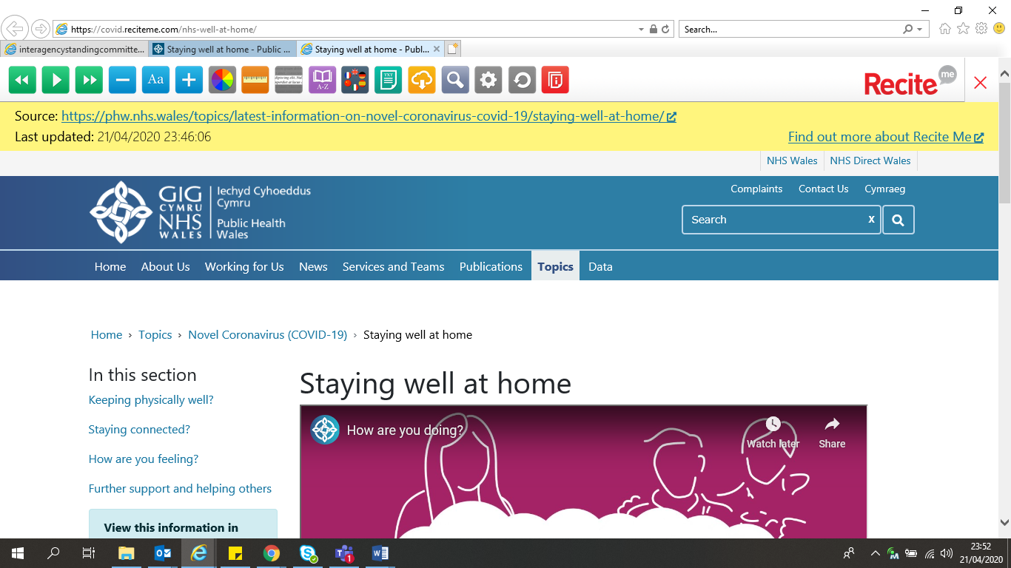

List of links for self-help materials in many languages

Simple, effective muscle relaxation exercise

Coronavirus easy read version – English only
https://drive.google.com/file/d/1pS22iSQTTRBN4af24isfIVK41qTr6g1p/view

https://www.doctorsoftheworld.org.uk/ covid-19 information in more than 40 languages.
Videos of the information are being released here: www.doctorsoftheworld.org.uk/coronavirus-video-advice/

The headspace app https://www.headspace.com/covid-19 is currently open to free access.

For Practitioners – front line workers

Stay at home posters

Urdu Benglai Gujarati Polish Punjabi

Romani Romanian Russian

Community Resources – not checked for language support provision
Bereavement support services - not checked for language support provision
The Community Well-Being Information Group, convened by the Mental Health and Learning Disability Division has a growing Directory of resources can be found on the internet pages
https://abuhb.nhs.wales/coronavirus/mental-health-and-well-being/

