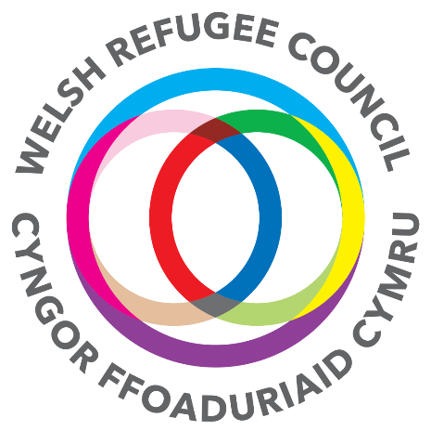

Welsh Refugee Council is seeking additional Trustees
[Unpaid – out of pocket expenses reimbursed]

The Welsh Refugee Council
For over 30 years we have been speaking out on behalf of those who are fleeing persecution, conflict and oppression; providing advice and practical support to asylum seekers and refugees seeking sanctuary in Wales.

We are their first step to safety, and we empower asylum seekers and refugees to build new futures and help create a society where respect and equality for all are paramount.

Our vision: “Working together for a Wales where refugees and asylum seekers are welcomed, respected and have access to protection, safety and dignity, that enables them to contribute and fully participate in the Welsh society”.

Our mission: “To improve the lives of asylum seekers and refugees in Wales through delivering specialist support and influencing policy and practice”.

There is more information about our work on the web-site -https://wrc.wales/

Our locations
We have four offices based in the heart of the communities we serve and covering the four dispersal areas of asylum seekers in Wales: Cardiff, Swansea, Newport & Wrexham.

Time commitments
Our Trustee Board meets six times a year and trustees also attend either the Strategy or Resources sub-committee which meet four times a year. Trustee meetings are held at our head office in Cardiff at 17:30- 19:30.

Skill and experience
We would welcome applications from potential trustees with a background and skills in one or more of the following areas:

- Human Rights  - Performance management  - Income generation/fundraising & financial management  - Human resources  - PR and communications | - Law  - Policy and Advocacy  - IT  - Experience as a refugee or asylum seeker

The Board has two places allocated for trustees of refugee background and we would particularly welcome applications from refugees or asylum seekers, as well as applications from members of ethnic minority communities.

We would expect all trustees to have a good understanding/knowledge of the refugee experiences and issues within a Welsh, UK or global perspective. We are particularly keen to achieve a diverse Board of Trustees and we welcome applications from all sections of the community.

Trustees would need to be able to make a commitment to the values and mission of the WRC and devote the necessary time, have strategic vision, independent judgement, an ability to think creativity and willingness to speak their mind.

All trustees are expected to comply with the Nolan Principles on public life and understand their roles and responsibilities as outlined within Charity Commission guidance CC3. The Essential Trustee

Application form
To apply, please contact the Chair – Harry Iles via harry.iles@trustee.wrc.wales for an application form. You will also need to supply a CV and two references with the completed form.

The closing date for applications is 22 March 2020 at 12 noon

We will then short-list candidates and interview potential trustees.

The interview date is Thursday 2 April 2020 from 17:30 in our head office - Cardiff

